# Lab 3: CSS

# Prepare your project:

* Download the provided starter code.
* Add the css-reset stylesheet (create an empty CSS file, then use the extension ctrl+alt+r).
* To have a clean html file, externalize your CSS rules in the external file cc/styles.css, notice the link tag in the head section:

<link rel=”stylesheet” href=”css/styles.css”>

# Style the table:

Open the provided code (home.html). Then, apply the following style to your table:

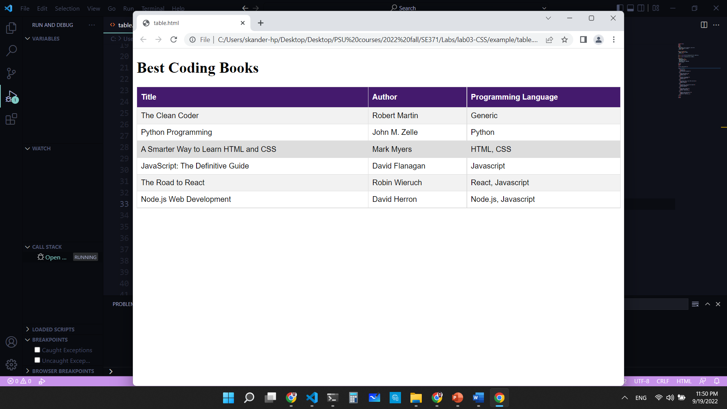

Fig 1. Style to apply to your table.

Steps:

1. For the table, use an ID selector and specify rules for:
   1. Font-family.
   2. The borders should be collapsed (border-collapse property).
   3. Width: must be 100 % of the parent.
2. For the td and th:
   1. Add a solid border of 1 pixel with a color of your choice.
   2. Add a padding of 8 pixels.
3. For the th:
   1. Add top and bottom paddings of 12 pixels.
   2. Align text to the left.
   3. Add a background color of your choice.
   4. Change the font color to create a strong contrast with the background.
4. Finally, for the tr:
   1. Add a css rule to highlight the row below the mouse position.
   2. Change the background color of even rows for better visibility.

# Style the form:

Open the provided from (register.html). Then, apply the rules that are shown in the picture to it:

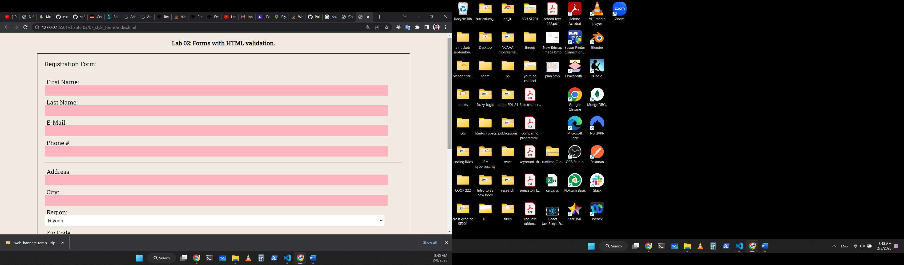

# Additional CSS rules:

1- Add a font-size property for each of your elements. For example, 16px for all paragraphs inside the main element and 24px for the header elements.

2- Change the color of the header font appropriately.

3- Add a background for paragraphs, example: background: *#eef*;

4- Add a text-transform property to your header to make it uppercase.

5- Add a margin for articles and sections to 20px auto. Add margins for texts of 5px auto.

6- Add padding to your images, nav, texts and aside elements.

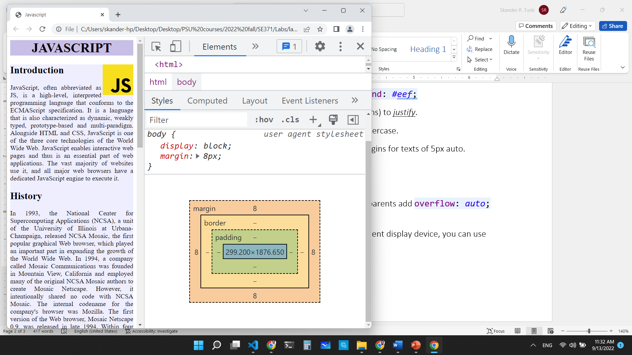

# **Optional** (for visual studio code users):

Instead of typing the HTML5 code skeleton for each new project, you can use the code snippet tool in VSCode. To add the HTML starter code to VSCode code snippets (code that is automatically inserted by the tool), visit the following repository and follow the documentation:

<https://github.com/skanderturki/vscode-html-snippets>